CS 2302 Data Structures

Fall 2019

Lab Report #2

Due: September 20, 2019

Professor: Olac Fuentes

TA: Anindita Nath

**Introduction**

In this lab the task was to implement different sorting methods that were given to us. The sorting algorithms were BubbleSort, QuickSort, an optimized quicksort, a quicksort that utilizes a stack, and a quicksort that uses only while loops to function. The goal of this lab was partially to refresh the different sorting methods but the main goal was to be able to view these sorting methods and determine in bigO notation, the runtimes of each of these functions.

**Proposed Solution Design and Implementation**

**Part #1:**

In part one I approached the Bubble Sort function by utilizing an iterative method to complete the task. I know that its run time is not as optimal as a recursive implementation but I was more confident in the iterative method to ensure a working code in the short term. Similarly I opted to use a single method implementation of quicksort rather than the in place method that utilizes 2 recursive functions.While slightly slower for larger arrays, my implementation for this lab worked well and was able to be transitioned fairly easily to the third part of part 1. For the modified quicksort I used the same code as my quicksort method but with a few simple checks to ensure that the optimization requirements that were stated in the lab instructions we're satisfied.

**Part #2:**

Part 2 was a bit more complex. I tried a few ways to integrate a stack into the quicksort but was met with errors at every turn. I ended up settling with attempting to utilize the recursion used in the original quicksort and use it to fill a stack then return in reverse order my answer then manually invert the answer to give a list that was sorted from least to greatest. For question 2 I did not make many changes to the original code i used for quicksort. Since my original method was very iterative to begin with i just replaced the recursive calls with a while loop keeping most of the code the same.

**Experimental Results**

**Part #1 Bubble Sort:**

This part of the lab was meant to verify that we were able to implement bubble sort. The time my method takes to runin bigO notation is O(N^2)

TEST 1 - [0,9,8,7,6,5,4,3,2,1] at index one

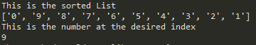

TEST 2 - [10,100,1000,10000,1] at index 2



**Part #1 QuickSort:**

This is my implementation of quick sort. It has a runtime of O(NlogN)

TEST 1 - [0,9,8,7,6,5,4,3,2,1] at index one

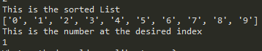

TEST 2 - [10,100,1000,10000,1] at index 2

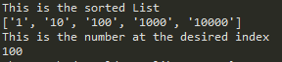

**Conclusion**

This lab seemed easy at first but as the week grew on i kept getting more and more and more errors. I plan to keep working on this to make this a working lab for me

**Appendix**

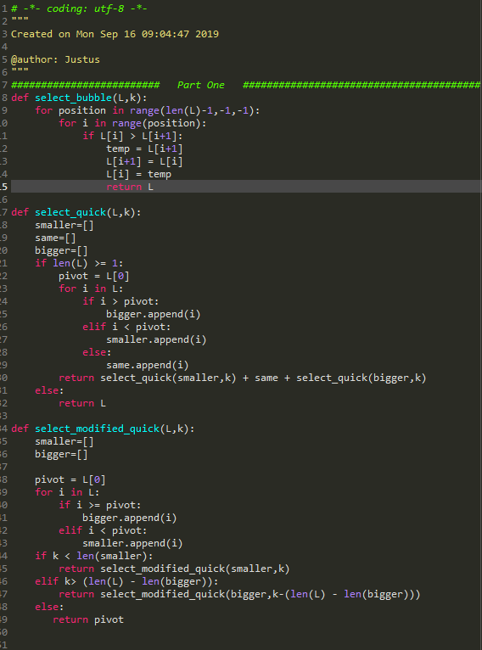

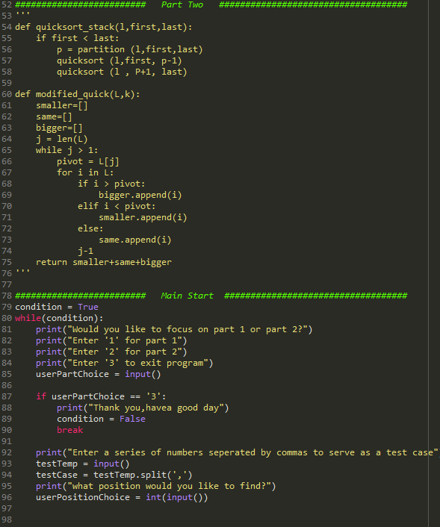

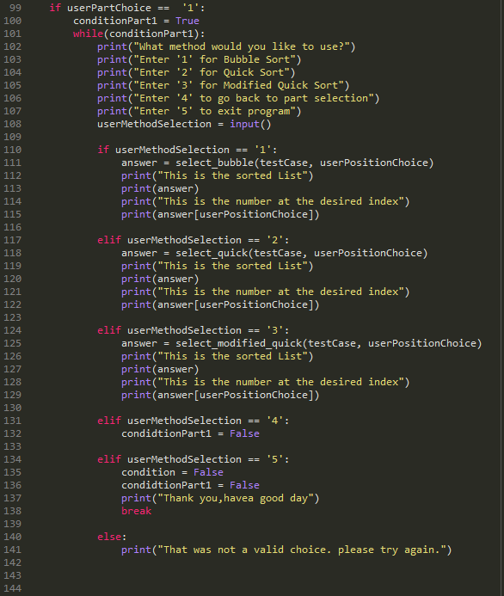

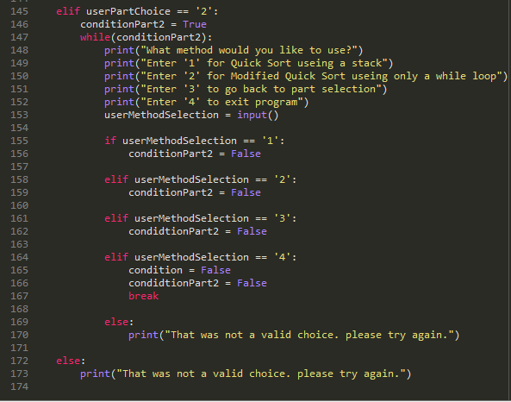

*I certify that this project is entirely my own work. I wrote, debugged, and tested the code being presented, performed the experiments, and wrote the report. I also certify that I did not share my code or report or provided inappropriate assistance to any student in the class*

*JustusFrausto*